EXPERIMENT 6 A

DATA VISUALIZATION USING POWER BI

Aim
To import, transform, analyze, and visualize diabetes patient data using Power BI Desktop and create interactive dashboards and reports for decision-making.

Sample Dataset

Diabetes Patient Dataset
ID | Age | Gender | Glucose | BMI | HbA1c
101 | 25 | Female | 110 | 22.5 | 5.4
102 | 45 | Male | 145 | 27.8 | 6.5
103 | 52 | Female | 160 | 30.2 | 7.2
104 | 38 | Male | 130 | 25.4 | 6.0
105 | 60 | Female | 180 | 32.1 | 8.0
106 | 48 | Male | 155 | 29.5 | 7.0

Algorithm 1 – Importing Data into Power BI
Step 1 - Open Power BI Desktop.
Step 2 - Select Home → Get Data.
Step 3 - Choose Excel or CSV.
Step 4 - Browse and select the diabetes dataset.
Step 5 - Click Load.
Step 6 - Verify the imported data.
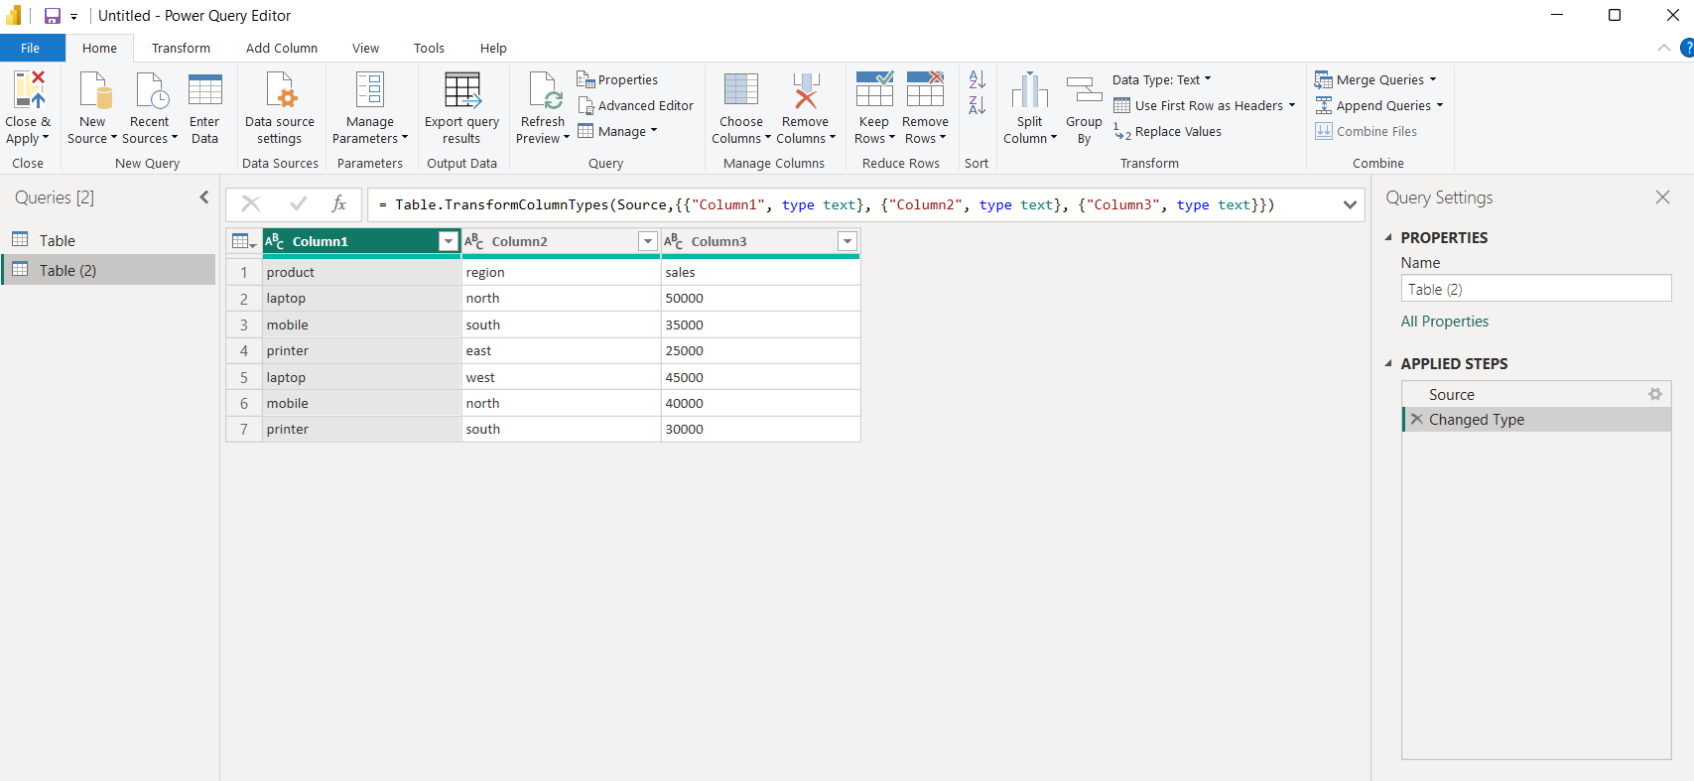

Algorithm 2 – Data Transformation using Power Query
Step 1 - Select Transform Data.
Step 2 - Open Power Query Editor.
Step 3 - Remove duplicate records.
Step 4 - Check and handle null values.
Step 5 - Verify column data types.
Step 6 - Click Close & Apply.
Output:
Product Sales
Laptop 50000
Mobile 35000
Printer 25000

Algorithm 3 – Creating a Bar Chart
Step 1 - Select Bar Chart visualization.
Step 2 - Drag Gender → X-axis.
Step 3 - Drag Glucose → Y-axis.
Step 4 - Format the chart.
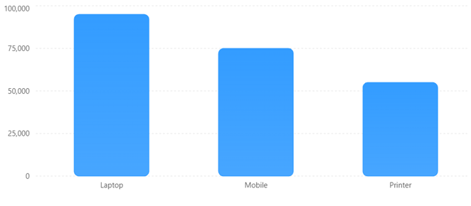

Algorithm 4 – Creating a Pie Chart
Step 1 - Select Pie Chart visualization.
Step 2 - Drag Gender → Legend.
Step 3 - Drag ID → Values.
Step 4 - Apply Data Labels.

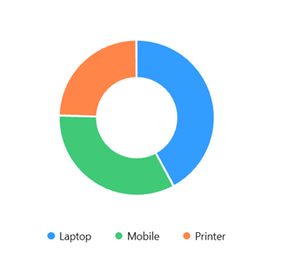

Algorithm 5 – Creating a KPI Card
Step 1 - Select Card visualization.
Step 2 - Drag Glucose field into the Card.
Step 3 - Select Average aggregation.
Step 4 - Apply formatting.

Algorithm 6 – Creating Slicers
Step 1 - Select Slicer visualization.
Step 2 - Drag Gender field into the slicer.
Step 3 - Enable filtering.
Step 4 - Observe the updated visuals.
Available Filters:
• North
• South
• East
• West
Dashboard Behavior
When North is selected:
Product Sales
Laptop 50000
Mobile 40000
Dashboard automatically updates.

Algorithm 7 – Creating DAX Calculations
Step 1 - Select the diabetes table.
Step 2 - Select New Measure.
Step 3 - Enter the DAX formula.
Step 4 - Press Enter.
Step 5 - Add the measure to a Card.

Average Glucose
Average Glucose = AVERAGE(Diabetes[Glucose])

Maximum Glucose
Maximum Glucose = MAX(Diabetes[Glucose])

Minimum Glucose
Minimum Glucose = MIN(Diabetes[Glucose])

Result
Thus, diabetes patient data was successfully imported, transformed, analyzed, and visualized using Microsoft Power BI. KPI cards, charts, slicers, DAX measures, and an interactive dashboard were successfully created.

